Assignment 4
Due date for this assignment: 2018-03-07, 23:59 IST.
1 point
An adiabatic heat exchanger is used to heat cold water at 15 °C entering at a rate of 5 kg/s by hot air at 90°C entering also at a rate of 10 kg/s. If the exit temperature of hot air is 20°C, the exit temperature of cold water is
27 °C
32 °C
49 °C
85 °C
1 point
A rigid tank contains 4 kg of an ideal gas at 5 atm and 80°C. Now a valve is opened, and half of mass of the gas is allowed to escape. If the final pressure in the tank is 2.2 atm, the final temperature in the tank is
70.4 °C
37.64 °C
-100 °C
20 °C
1 point
Steam is compressed by an adiabatic compressor from 0.2 MPa and 150°C to 0.8 MPa and 350°C at a rate of 2.30 kg/s. The power input to the compressor is
511 kW
393 kW
302 kW
904 kW
1 point
Air is contained in a variable-load piston-cylinder device equipped with a paddle wheel. Initially, air is at 500 kPa and 27°C. The paddle wheel is now turned by an external electric motor until 30 kJ/kg of work has been transferred to air. During this process, heat is transferred to maintain a constant air temperature while allowing the gas volume to triple. Calculate the required amount of heat transfer.
44.6 kJ/kg
64.6 kJ/kg
24.7 kJ/kg
57.8 kJ/kg
1 point
Liquid water at 15 °C is heated in a chamber by mixing it with saturated steam. Liquid water enters the chamber at the steam pressure at a rate of 4.6 kg/s and the saturated steam enters at a rate of 0.23 kg/s. The mixture leaves the mixing chamber as a liquid at 45°C. If the surroundings are at 15°C, determine the enthalpy of saturated steam entering the chamber.
2697 kJ/kg
4500 kJ/kg
1500 kJ/kg
1803 kJ/kg
1 point
Steam enters a diffuser steadily at 0.5 MPa, 300°C, and 122 m/s at a rate of 4 kg/s. The inlet area of the diffuser is
15.2 cm²
50.1 cm²
105.2 cm²
171.3 cm²
1 point
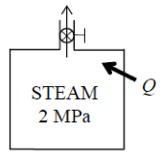
0.2-m³ rigid tank equipped with a pressure regulator contains steam at 2 MPa and 300°C. The steam in the tank is now heated. The regulator keeps the steam pressure constant by letting out some steam, but the temperature inside rises. Determine the amount of heat transferred when the steam temperature reaches 500°C.
606 kJ
500 kJ
436 KJ
789 kJ
1 point
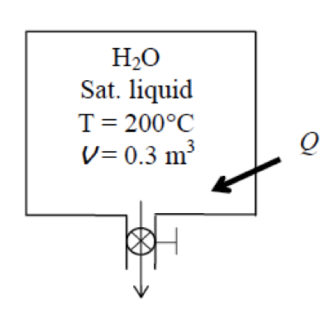
A 0.3-m³ rigid tank is filled with saturated liquid water at 200°C. A valve at the bottom of the tank is opened, and liquid is withdrawn from the tank. Heat is transferred to the water such that the temperature in the tank remains constant. Determine the amount of heat that must be transferred by the time one-half of the total mass has been withdrawn.
2308 kJ
866 kJ
129 kJ
850 kJ
1 point
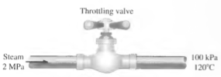
Saturated liquid-vapor mixture of water, called wet steam, in a steam line at 2000 kPa is throttled to 100 kPa and 120°C. What is the quality in the steam line?
0.957
1.324
0.567
0.349
1 point
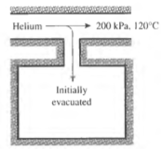
A rigid, insulated tank that is initially evacuated is connected through a valve to a supply line that carries helium at 200 kPa and 120°C. Now the valve is opened, and helium is allowed to flow into the tank until the pressure reaches 200 kPa, at which point the valve is closed. Determine the flow work of the helium in the supply line.
564 kJ/kg
816 kJ/kg
934 kJ/kg
325 kJ/kg
You may submit any number of times before the due date. The final submission will be considered for grading.

